

100 DAYS RTL PART-1

Day 21: CONDITIONAL OPERATORS

Day 22: ARITHMETIC OPERATORS

Day 23: BITWISE OPERATORS

Day 24: LOGICAL OPERAROES

Day 25: RELATIONAL OPERATORS

Day 26: CASE EQUALITY OPERATORS

Day 27: REDUCTION OPERATORS

Day 28: SHIFT OPERATORS

Day 29: CONCATENATION OPERATORS

Day 30: REPLICATION OPERATOR

Day 21: Conditional Operators
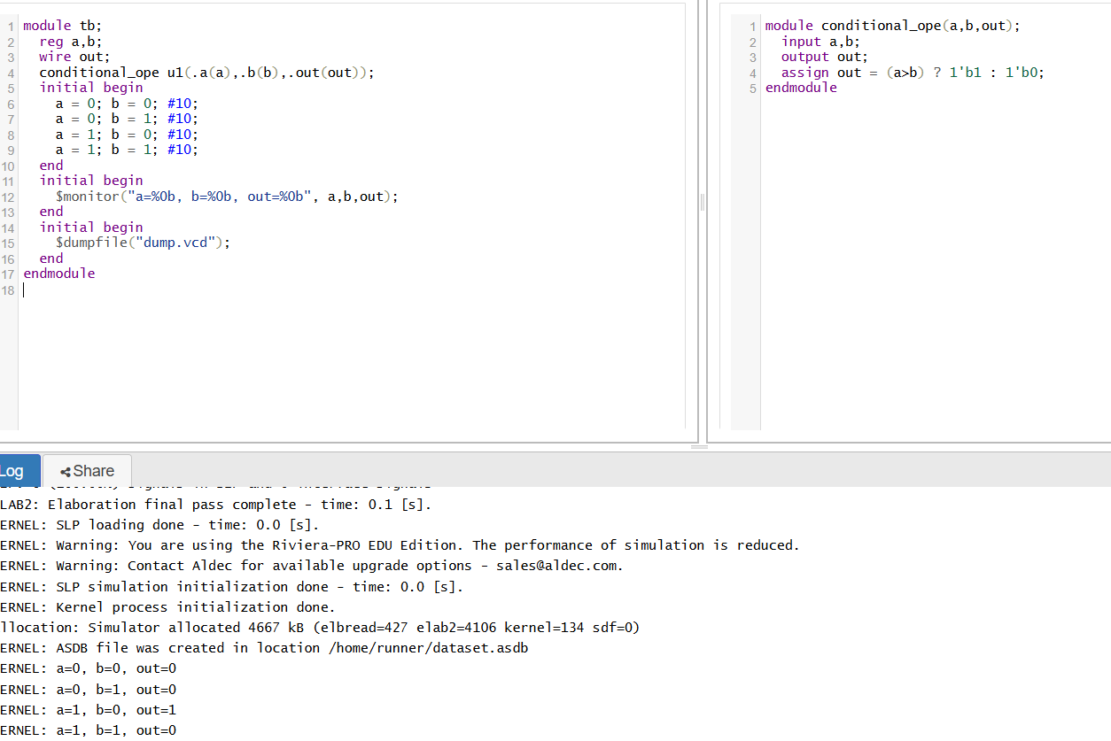

🧠 Explanation:
- a and b: These are 1-bit inputs (can be 0 or 1).
- out: This is the 1-bit output.
- assign out = (a == b)? 1'b1: 1'b0;
This is a conditional (ternary) operator statement.

🔍 How it works:
assign out = (a == b) ? 1'b1 : 1'b0;
is equivalent to:
if (a == b)
out = 1;
else
out = 0;
- If a is equal to b (both are 0 or both are 1), out becomes 1.
- If a is not equal to b, out becomes 0.

📌 Conditional Operator Syntax:
(condition) ? value_if_true : value_if_false;

✅ Example Cases:
a | b | a==b | out
0 | 0 | 1 | 1
0 | 1 | 0 | 0
1 | 0 | 0 | 0
1 | 1 | 1 | 1

Day 22: Arithmetic Operators
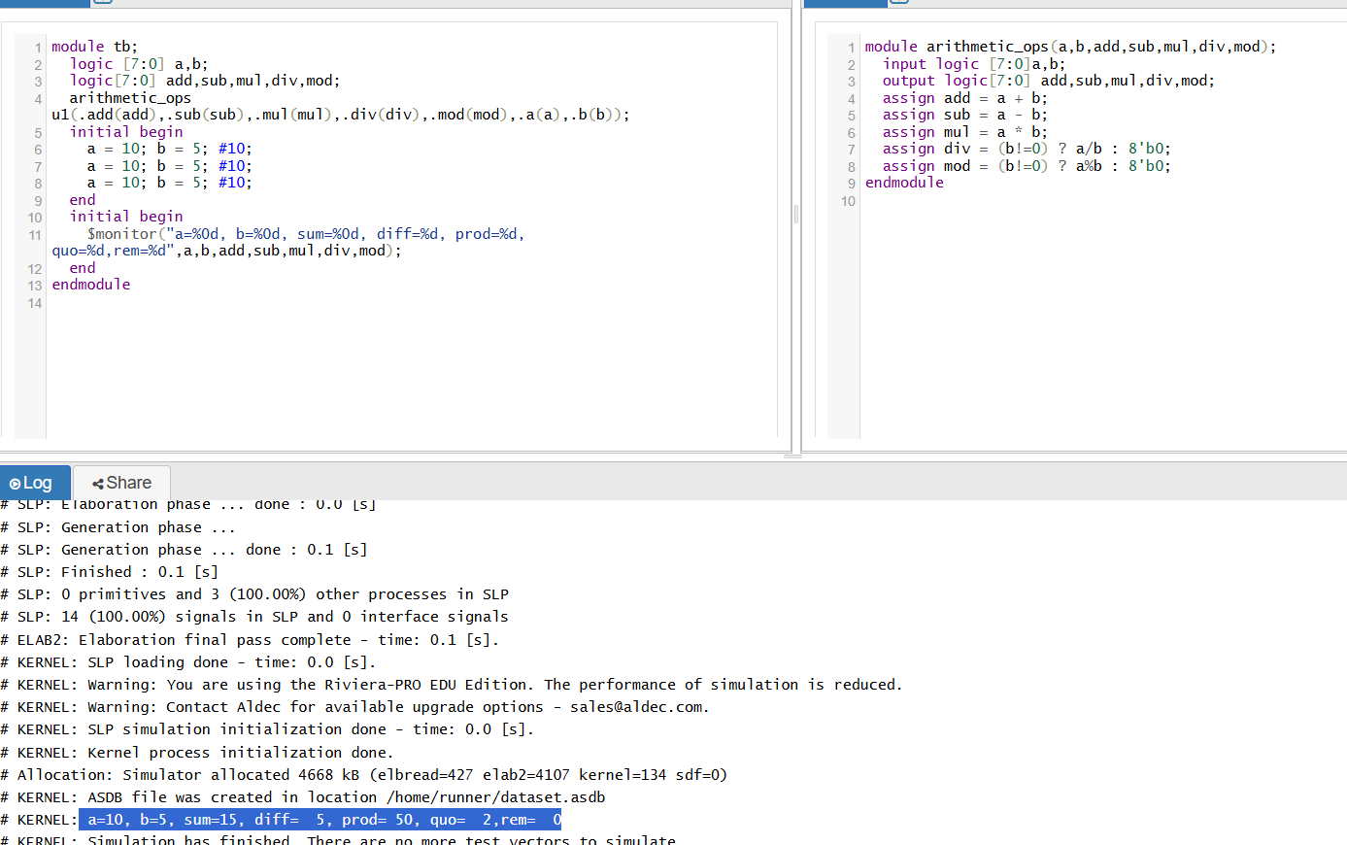
🧠 Explanation:
✅ Inputs:
- a, b: 8-bit unsigned numbers (values from 0 to 255).
✅ Outputs:
- add: sum of a and b
- sub: difference of a and b
- mul: multiplication result (can go up to 16 bits → 255 x 255 = 65025)
- div: quotient when a is divided by b
- mod: remainder (modulus) when a is divided by b

🧮 Arithmetic Operators Used:
Operation | Symbol | Example | Description
Addition | + | a + b | Adds a and b
Subtraction | - | a - b | Subtracts b from a
Multiplica. | * | a * b | Multiplies a and b
Division | / | a / b | Divides a by b, gives quotient
Modulus | % | a % b | Gives remainder of a divided by b

⚠️ Why check b != 0?
Division and modulus by 0 is undefined, and will cause simulation issues or errors. So we use:
(b != 0) ? a / b : 8'b0;
This prevents runtime errors.

✅ Example:
a | b |  | add | sub | mul | div | mod
10 | 5 |  | 15 | 5 | 50 | 2 | 0
20 | 6 |  | 26 | 14 | 120 | 3 | 2
8 | 0 |  | 8 | 8 | 0 | 0 | 0

Day 23: Bitwise Operators
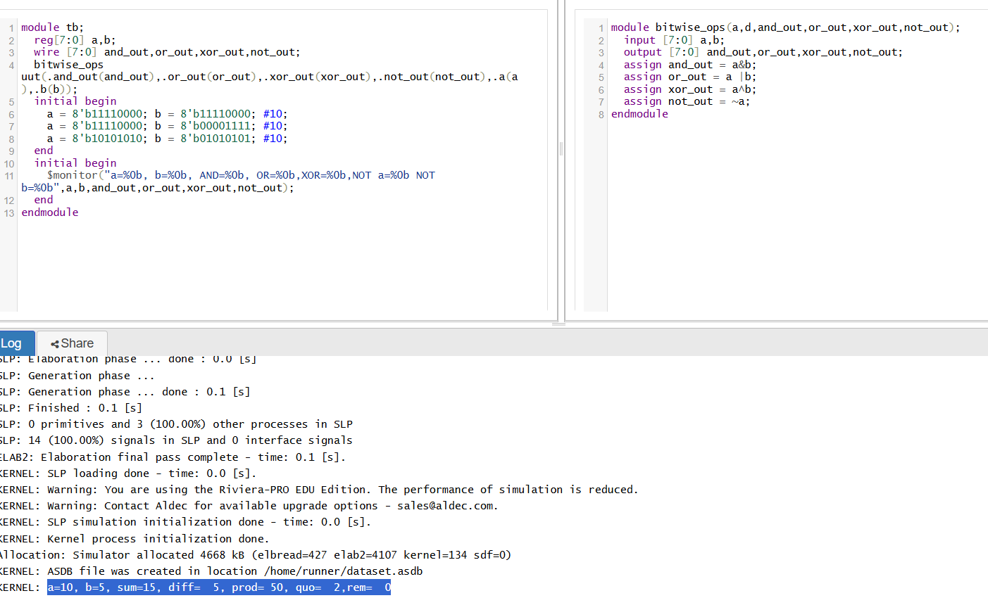
🧠 Explanation:
a = 4'b1100;
b = 4'b1010;
Then:
Operation | Expression | Result
Bitwise AND | a & b | 1000
Bitwise OR | `a | b`
Bitwise XOR | a ^ b | 0110
Bitwise NOT (a) | ~a | 0011

✅ Summary of Each Output:
- and_out: 1 only if both bits are 1.
- or_out: 1 if any one bit is 1.
- xor_out: 1 if bits are different.
- not_out: Inverts each bit of input a.

Day 24: Logical Operators
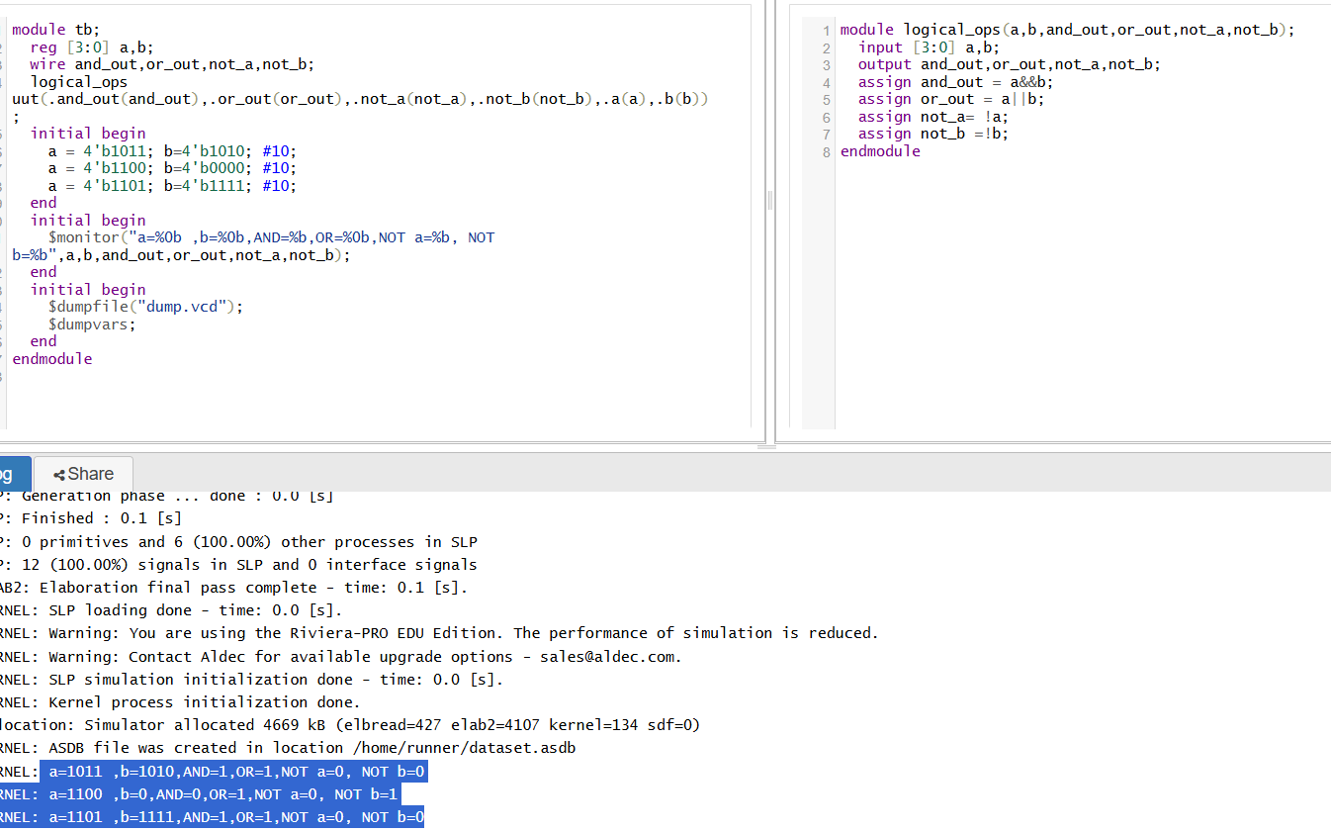
✅ Logical Operators in Verilog (Theory Only)
Logical operators in Verilog are used to evaluate true/false conditions on entire vectors, not bit-by-bit. A non-zero value is considered true (1), and zero is false (0).
🔹 Operators & Their Functions:
Operator | Description | Example
&& | Logical AND – true if both are true | a && b
` |  | `
! | Logical NOT – true if input is false (0) | !a

🔹 Behavior Based on Inputs:
Given:
- a = 4'b1011 → non-zero → true
- b = 4'b0000 → zero → false
Then:
- a && b → false (since b is false)
- a || b → true (since a is true)
- !a → false (a is not zero)
- !b → true (b is zero)

🔹 Key Points:
- Logical operators evaluate whether entire signals are zero or non-zero.
- They return 1-bit true (1) or false (0).
- Used in conditional logic, decision-making, and control structures like if, while, etc.

Day 25: Relational Operators
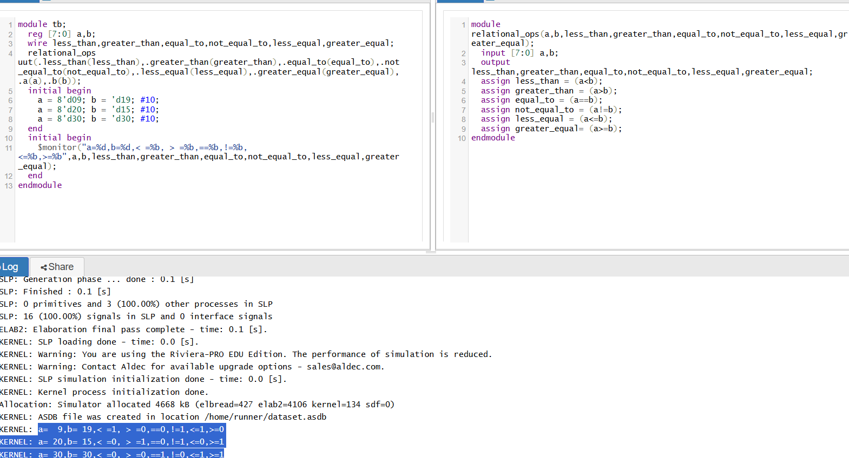
✅ Relational Operators in Verilog
These operators compare two numbers and return a single-bit result:
- 1 (true) if the condition is satisfied
- 0 (false) otherwise

🔹 Operators and Their Meanings:
Operator | Meaning | Syntax | Example (a = 9, b = 19) | Result
< | Less than | a < b | 9 < 19 | 1
> | Greater than | a > b | 9 > 19 | 0
== | Equal to | a == b | 9 == 19 | 0
!= | Not equal to | a != b | 9 != 19 | 1
<= | Less than or equal to | a <= b | 9 <= 19 | 1
>= | Greater than or equal to | a >= b | 9 >= 19 | 0

🔹 Given Input Sets:
⏱ 1. Time = 0 ns
a = 8'd09; b = 8'd19;
- a < b → 1
- a > b → 0
- a == b → 0
- a != b → 1
- a <= b → 1
- a >= b → 0
⏱ 2. Time = 10 ns
a = 8'd20; b = 8'd15;
- a < b → 0
- a > b → 1
- a == b → 0
- a != b → 1
- a <= b → 0
- a >= b → 1
Day 26: Case Equality Operator
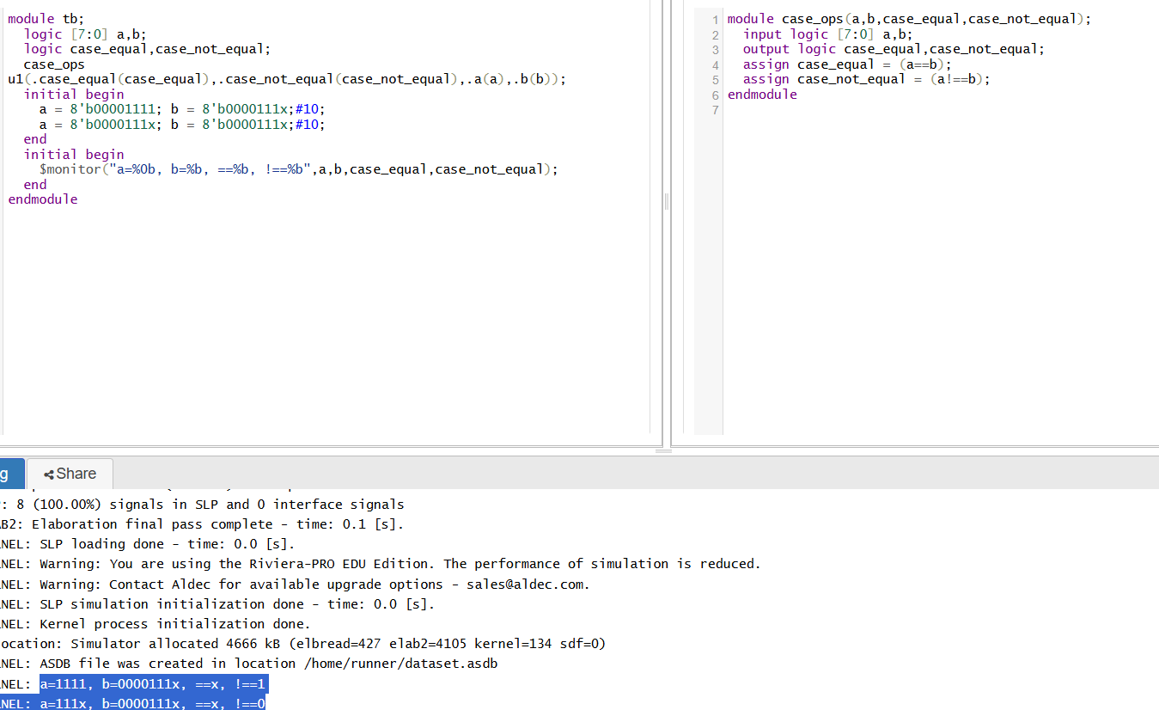

🛡️ Verilog/SystemVerilog: === (Case Equality)

- Operates on 4-state logic: Each bit of a and b can be 0, 1, x, or z.
- Strict bitwise comparison: Compares each corresponding bit, including unknown (x) or high-impedance (z) states.

- Output: Always yields a definite 1 (match) or 0 (mismatch); it never returns unknown (x).
- Differences from ==:
  - == performs a 2-state comparison (only 0/1), and if either operand has x or z it leads to an unknown (x) result
  - === treats unknowns as comparable values, ensuring deterministic outcomes .

🧠 Ruby: === (Case Equality / Threequals)
- Conceptual meaning: Think “Does the left-hand object include or recognize the right-hand object?”
- Behavior varies by type:

  - Range: a..b === x → checks if x falls within the range
  - Class/Module: String === obj → returns true if obj.is_a?(String)
  - Regexp: /foo/ === string → matches substring .
  - Default (Object): Alias for simple == unless overridden
Language | Operator | Purpose | Output
Verilog | === | Bitwise 4-state equality (0/1/x/z) | 1 or 0
Verilog | == | 2-state equality (0/1), unknowns → x | 1, 0, or x
Ruby | === | Pattern, type, range, regex membership | true or false

Day 27: Reduction Operator
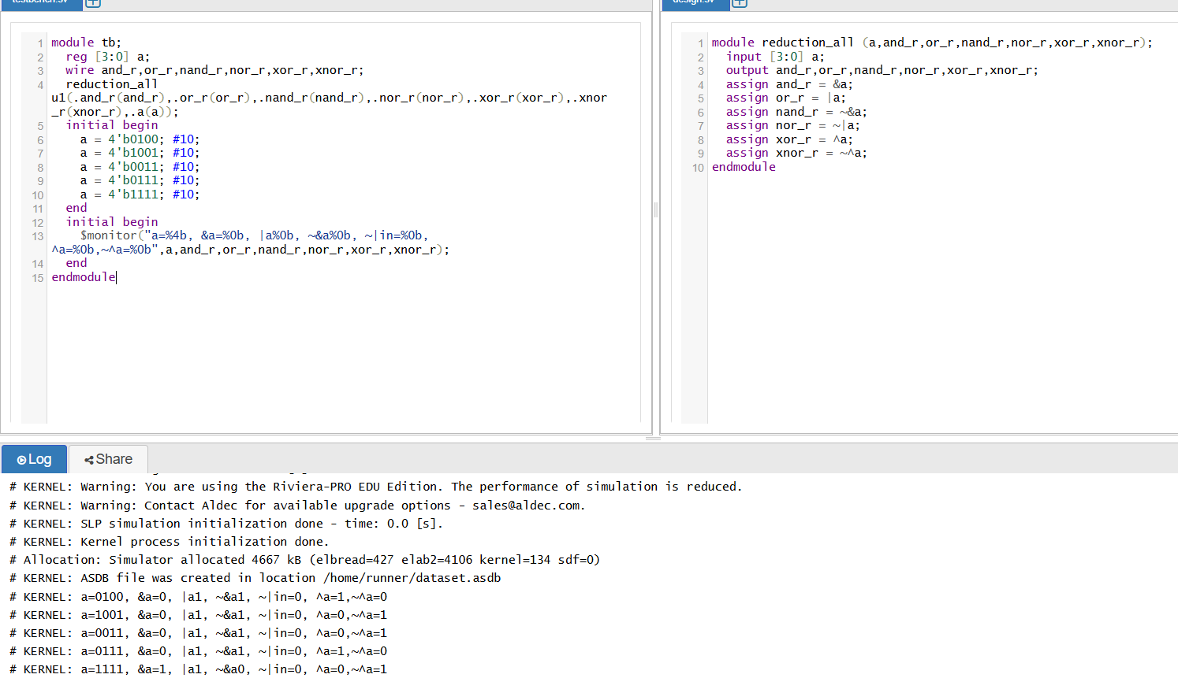

What Are Reduction Operators?
- Unary operators that process one vector (a) and reduce all its bits into a single-bit result
- They perform a sequential fold: the operation is applied first to the leftmost two bits, then that result with the next bit, and so on until all bits are consumed.

🔍 Specific Operators & Their Meaning
For a[3:0], the following reduction operators are used:
- &a (AND reduction)
Output is true if all bits of a are 1.
- |a (OR reduction)
True if any bit of a is 1.
- ^a (XOR reduction)
True when there's an odd number of 1s in a (odd parity)
- ~&a (NAND reduction)
The negation of the AND result: true as long as not all bits are 1.
- ~|a (NOR reduction)
The negation of the OR result: true only if no bit is 1 (i.e., all zeros).
- ~^a (XNOR reduction)
The negation of XOR: true when there's an even number of 1s in a (even parity)

🎯 Purpose of Each Output
With declaration:
verilog
CopyEdit
input [3:0] a;
output and_r, or_r, nand_r, nor_r, xor_r, xnor_r;
⚙️ Why They Matter
- Implement multi-input logic gates in a concise, synthesizable manner—e.g., 4-input AND uses &a
- Provide efficient detection of global conditions:
  - All ones (and_r)
  - Any one (or_r)
  - Parity (xor_r / xnor_r)
Day 28: Shift Operator
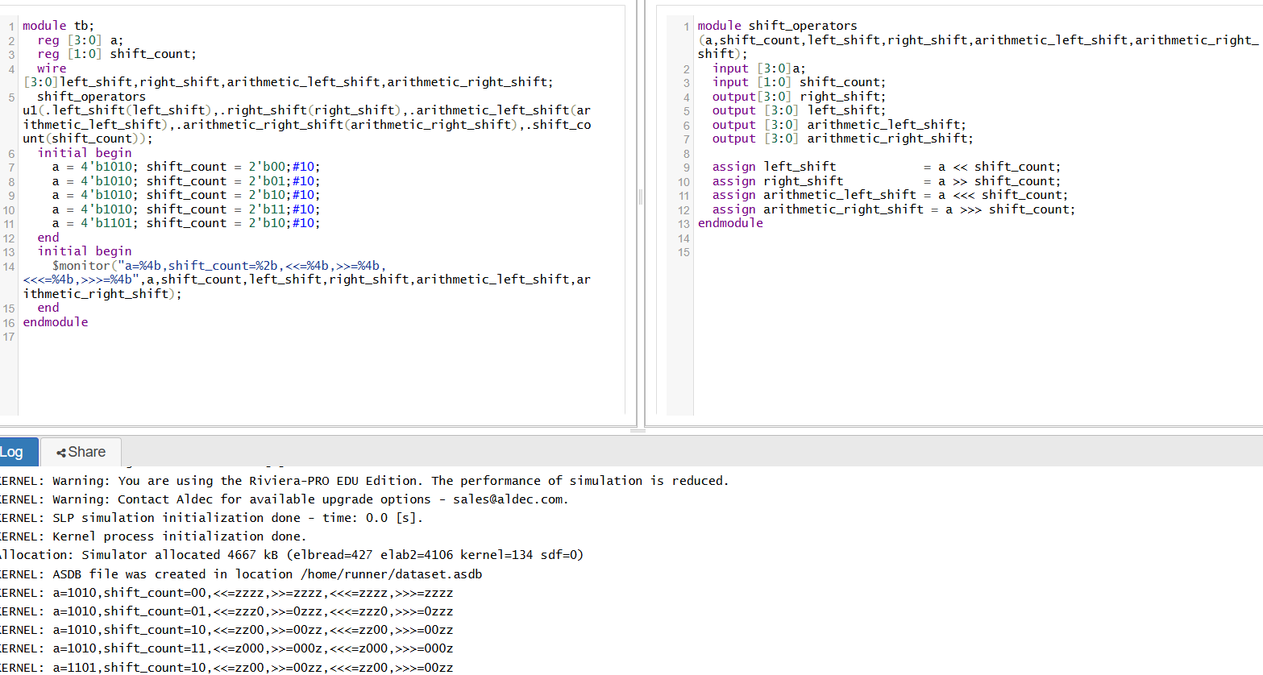
🔁 Shift Operators Overview
Verilog provides four shift operators:
- Logical left shift (<<)
- Logical right shift (>>)
- Arithmetic left shift (<<<)
- Arithmetic right shift(>>>)
- ➡️ Logical Shifts (<<, >>)
- Logical Left Shift (a << shift_count)
  - Moves bits left by shift_count positions.
  - Vacated LSBs (right side) are filled with zeros.
- Logical Right Shift (a >> shift_count)
  - Moves bits right by shift_count positions.
  - Vacated MSBs (left side) are filled with zeros.
➿ Arithmetic Shifts (<<<, >>>)
- Arithmetic Left Shift (a <<< shift_count)
  - Functionally identical to logical left shift: vacated LSBs are set to zero.
- Arithmetic Right Shift (a >>> shift_count)
  - Moves bits right, but vacated MSBs are filled with the original sign bit (a’s MSB).
  - Thus, if a is signed, the shift preserves sign.
📦 Summary of Theoretical Behavior
Output Name | Operator | Behavior
left_shift | a << shift_count | Bits shifted left, LSBs set to zero; unsigned multiplication by 2ⁿ.
right_shift | a >> shift_count | Bits shifted right, MSBs set to zero; unsigned division by 2ⁿ.
arithmetic_left_shift | a <<< shift_count | Same as logical left; zeros filled on the right.
arithmetic_right_shift | a >>> shift_count | Bits shifted right, MSBs filled with original MSB; signed division by 2ⁿ with sign-preserving.

✅ Why This Matters
- Implement efficient arithmetic operations in hardware without multipliers/dividers.
- Create shift registers and barrel shifters.
- Preserve sign integrity in signed arithmetic flows using >>>.
Day 29: Concatenation Operator
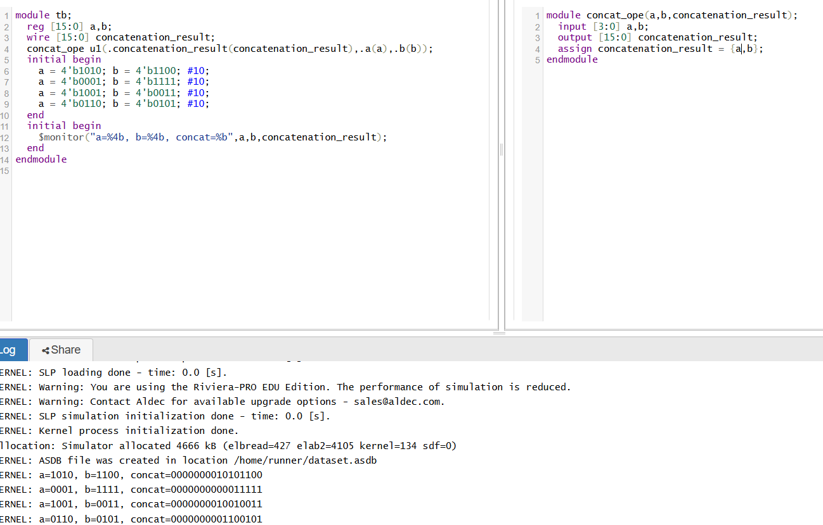

📦 What Concatenation Does
- The concatenation operator { } combines multiple signals (vectors, bits, constants) side by side.
- The order matters: items listed first form the most significant bits, and items listed last form the least significant bits
- The total bit width of the result equals the sum of the widths of each component.

🧩 How It Applies to a and b
- a and b are each 4 bits wide.
- When concatenated into a 16-bit output, you may fractionally place them multiple times.

🧠 Why It's Useful
- Combining buses: Useful when you need to pack smaller buses into larger ones—for address/data formatting, bus interfacing, or control signals
- Creating structured data: Ideal for building larger words from multiple fields.
- Synthesizes cleanly: It maps directly to physical wiring (wire bundles) in hardware.

✅ Quick Recap
Property | Details
Syntax | {item1, item2, …}
Order | First = MSBs, last = LSBs
Width | Sum of component widths
Use cases | Building buses, structuring signals, data packing
Hardware view | Simple parallel wiring — no computation
Day 30: Replication Operator
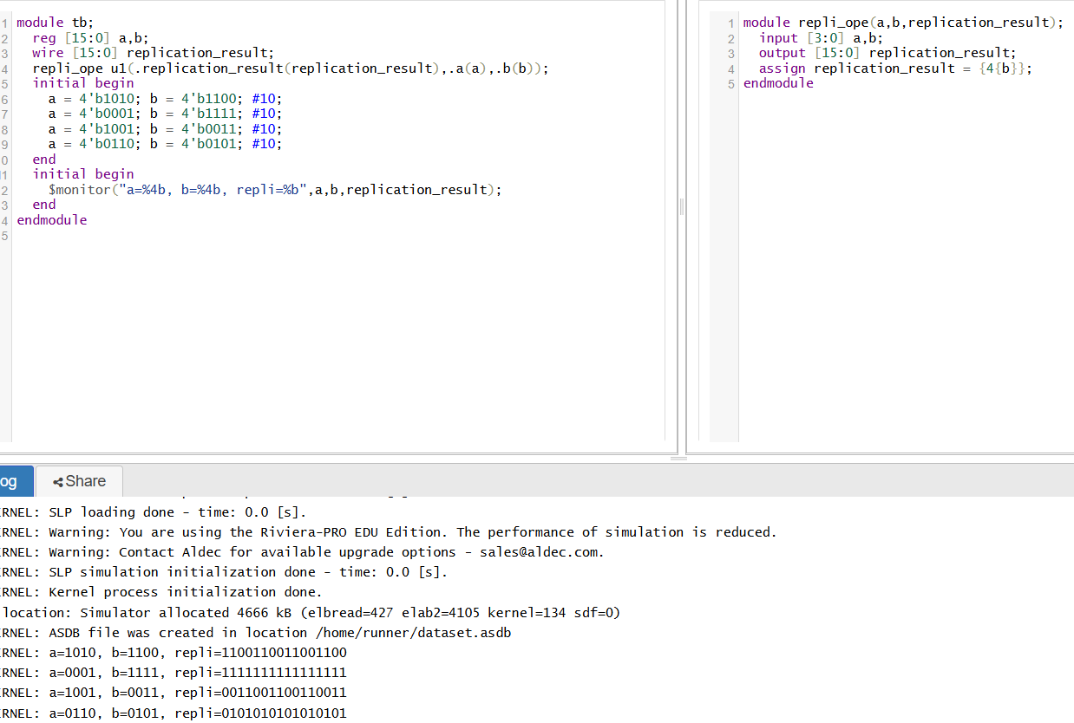

🔁 What the Replication Operator Does
- Syntax: {N{expression}}
  - N is a constant (non-negative, cannot be x, z, or a variable).
  - The expression (e.g., a or b) is repeated N times, and all copies are concatenated in sequence.
- Essentially, it’s a shorthand for writing {expr, expr, ..., expr} N times .

📌 What Happens with 4-bit a and b to Make 16-bit replication_result
With a and b each 4 bits, to get a 16-bit output you might use:
replication_result = {4{a}}; // aaaa (4 copies)
replication_result = {2{a, b}}; // ab ab (repeated twice)
Each replication simply duplicates the bit pattern, stitching them side-by-side.

🛠️ Why It’s Useful
- Bus replication: Efficiently build wider vectors without manual duplication.
- Sign extension: Repeat the sign bit to extend a signed number cleanly
- Parameterized generation: Handy in configurable designs to replicate patterns based on constants.

✅ Summary Table
Feature | Explanation
Syntax | {N{expr}}
N requiremet | Must be constant and ≥ 0 (cannot be variable or undefined)
Resulting width | Width(expr) × N
Use-cases | Bus replication, sign-extension, parameterized vector construction
Hardware view | Physically concatenates N parallel copies of the expression

✨ In theory: The replication operator wraps the expression in curly braces with a multiplier, auto-generates multiple copies, and concatenates them — a concise, synthesis-friendly method for replicating signal patterns.



